[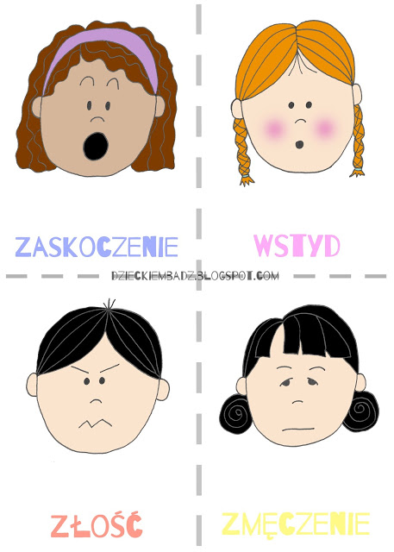](https://4.bp.blogspot.com/-wusNt4CxaX8/WXzS24XttwI/AAAAAAAACx4/fW0m7V-JdvUY3D8j4Ob1iIWsNa6lZYJPQCLcBGAs/s1600/Memory-Emocje1.jpg)

[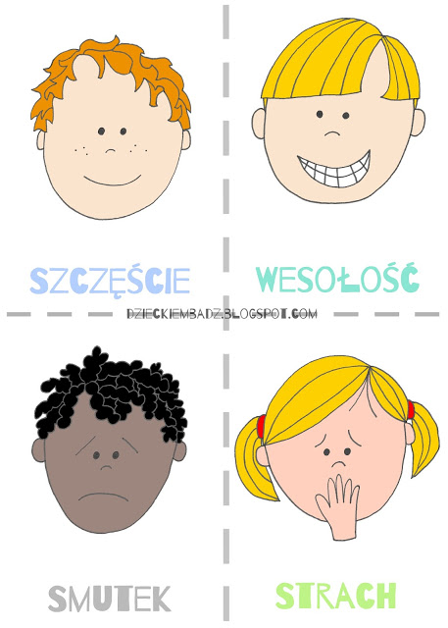](https://3.bp.blogspot.com/-ZiKFREhkEpU/WXzS25Dkr8I/AAAAAAAACx0/wG8oCY2-yMc0_GROqQ0XSYShzJwiUTlegCLcBGAs/s1600/Memory-Emocje.jpg)

[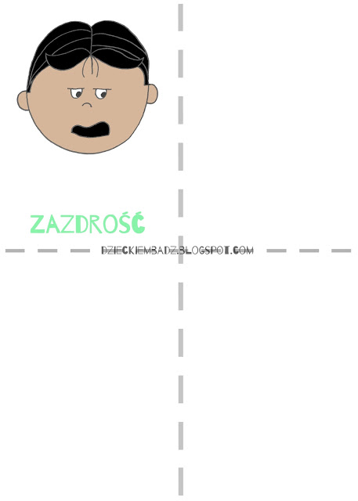](https://1.bp.blogspot.com/-PchMqAzHNas/WXzS2cuXCeI/AAAAAAAACxw/7W1zxTZTyoMKazQ0DxghZ7tg-tVBUzmEACLcBGAs/s1600/Memory-Emocje2.jpg)