**BOCIAN BIAŁY**

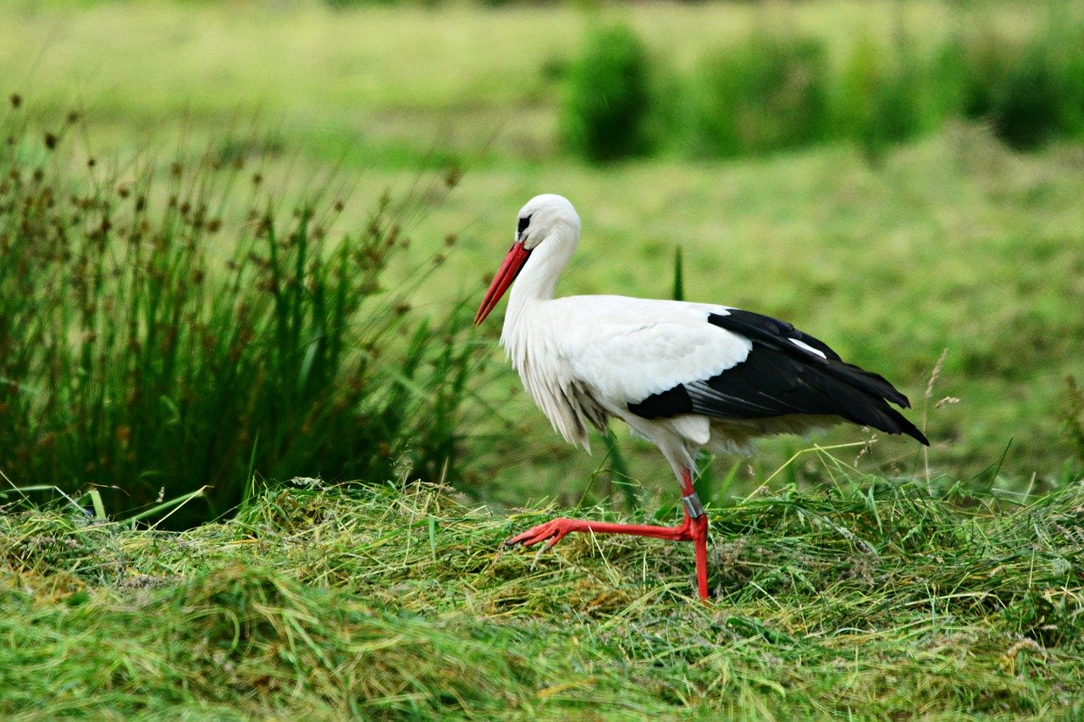

**BOCIAN CZARNY**

